#include <stdio.h>
#include <string>

// Function to get performance category based on marks
const char* getPerformance(int marks) {
if (marks >= 90) return "Excellent";
if (marks >= 75) return "Good";
if (marks >= 50) return "Average";
if (marks >= 40) return "Below Average";
return "Fail";
}

// Function to calculate average marks
float calculateAverage(int marks[], int size) {
int total = 0;
for (int i = 0; i < size; i++) {
total += marks[i];
}
return (float)total / size;
}

// Function to find subject with highest marks
int findBestSubject(int marks[], int size) {
int highest = 0;
for (int i = 1; i < size; i++) {
if (marks[i] > marks[highest]) {
highest = i;
}
}
return highest;
}

// Function to find subject with lowest marks
int findWeakestSubject(int marks[], int size) {
int lowest = 0;
for (int i = 1; i < size; i++) {
if (marks[i] < marks[lowest]) {
lowest = i;
}
}
return lowest;
}

int main() {
// Arrays to store subject names and marks
char subjects[5][30] = {"Mathematics", "Physics", "Programming", "Chemistry", "English"};
int marks[5];

// Arrays for tracking improvement and good performance
char needsImprovement[5][30];
char goodPerformance[5][30];
int improvementCount = 0;
int goodCount = 0;

// Variables for statistics
int totalMarks = 0;
int passedSubjects = 0;

printf("*** Student Learning Progress Tracker ***\n\n");
printf("Please enter marks for each subject (0-100):\n\n");

// Input marks for each subject
for (int i = 0; i < 5; i++) {
printf("Enter marks for %s: ", subjects[i]);
scanf("%d", &marks[i]);

// Input validation
while (marks[i] < 0 || marks[i] > 100) {
printf("Invalid marks! Please enter between 0 and 100: ");
scanf("%d", &marks[i]);
}

totalMarks += marks[i];

// Count passed subjects (marks >= 40)
if (marks[i] >= 40) {
passedSubjects++;
}

// Categorize subjects for improvement and good performance
if (marks[i] < 50) {
strcpy(needsImprovement[improvementCount], subjects[i]);
improvementCount++;
} else if (marks[i] >= 75) {
strcpy(goodPerformance[goodCount], subjects[i]);
goodCount++;
}
}

// Display detailed performance report
printf("\n\n--- PERFORMANCE REPORT CARD ---\n");
printf("========================================\n");
printf("SUBJECT\t\t| MARKS\t| PERFORMANCE\n");
printf("========================================\n");

for (int i = 0; i < 5; i++) {
printf("%s\t| %d\t| %s\n", subjects[i], marks[i], getPerformance(marks[i]));
}

// Display statistics
printf("\n--- OVERALL STATISTICS ---\n");
printf("Total Marks: %d/500\n", totalMarks);
printf("Average Marks: %.2f\n", calculateAverage(marks, 5));
printf("Subjects Passed: %d/5\n", passedSubjects);

// Find and display best subject
int bestIndex = findBestSubject(marks, 5);
printf("Best Subject: %s (%d marks)\n", subjects[bestIndex], marks[bestIndex]);

// Find and display weakest subject
int weakestIndex = findWeakestSubject(marks, 5);
printf("Weakest Subject: %s (%d marks)\n", subjects[weakestIndex], marks[weakestIndex]);

// Display subjects needing improvement
printf("\n--- IMPROVEMENT AREAS ---\n");
if (improvementCount == 0) {
printf("Excellent! No subjects need improvement.\n");
} else {
printf("Subjects that need more attention:\n");
for (int i = 0; i < improvementCount; i++) {
printf("- %s\n", needsImprovement[i]);
}
printf("Focus on practicing these subjects regularly.\n");
}

// Display subjects with good performance
printf("\n--- STRONG AREAS ---\n");
if (goodCount == 0) {
printf("Keep working hard! No subjects in 'Good' or above category yet.\n");
} else {
printf("Subjects where you're doing well:\n");
for (int i = 0; i < goodCount; i++) {
printf("- %s\n", goodPerformance[i]);
}
printf("Maintain this performance!\n");
}

// Overall performance message
printf("\n--- FINAL REMARKS ---\n");
float average = calculateAverage(marks, 5);
if (average >= 75) {
printf("Outstanding performance! Keep up the excellent work!\n");
} else if (average >= 50) {
printf("Good performance! There's room for improvement.\n");
} else if (average >= 40) {
printf("You passed, but need to work harder.\n");
} else {
printf("Need significant improvement. Don't give up!\n");
}

return 0;
}

OUTPUT:
Step1:
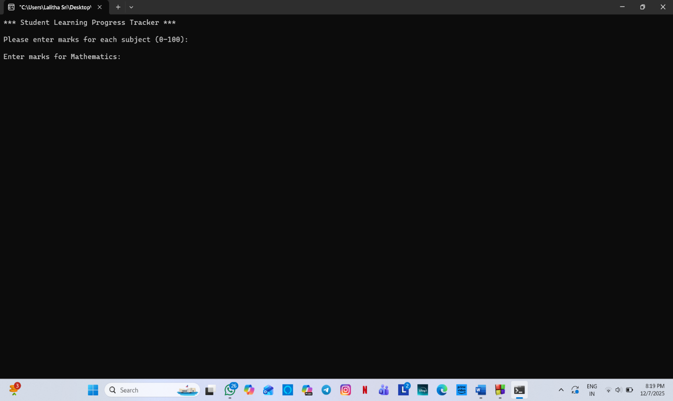
Step2:
